ECEN340
Lab 7 - Finite State Machines

Objectives
- Learn how to design simple finite state machines
- Learn how to design timers and precise clock frequencies
- Learn how to implement a simple state machine in Verilog

Procedure

Design and implement a traffic light controller for a Main street / Center street intersection. The recommended state graph for the controller is:

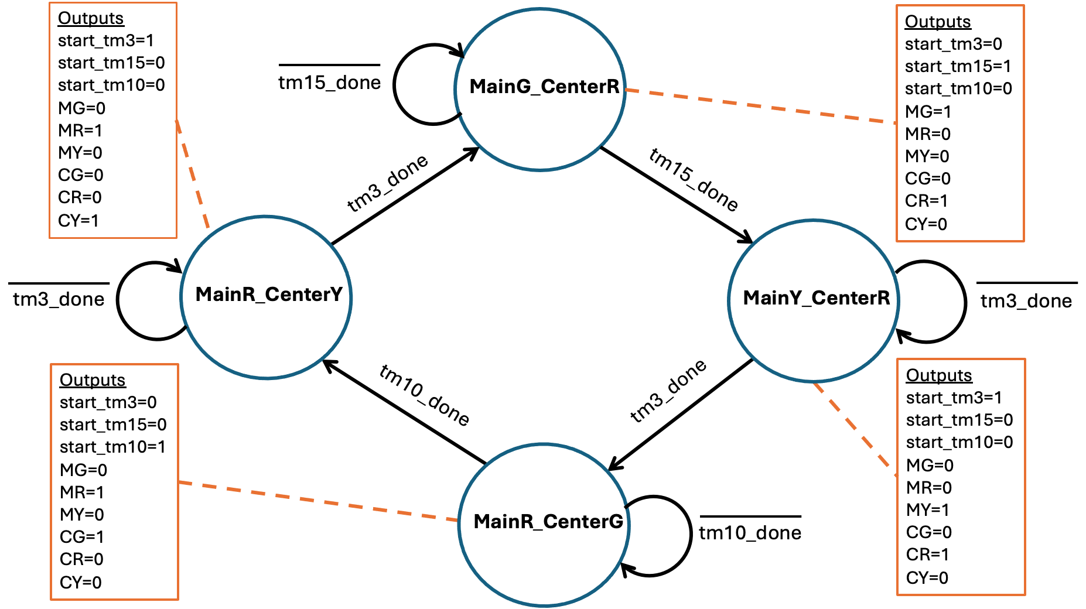

    - LED 0: Main Street Green Light
    - LED 1: Main Street Yellow Light
    - LED 2: Main Street Red Light
    - LED 4: Center Street Green Light
    - LED 5: Center Street Yellow Light
    - LED 6: Center Street Red Light

Key Requirements:
- The state machine clock rate will be 100MHz
- Use parameters to represent the state names
- Design a state machine with Moore outputs
- Use a dedicated "always" block with a case statement to implement the next state logic
- Use a dedicated "always" block to advance the current state to the next state
- Design a 1 Hz clock signal for the state machine
- Design a 3 second timer for the yellow lights
- Design a 15 second timer for the main street green light
- Design a 10 second timer for the center street green light

State Names
- MainG_CenterR - Main street light is green, Center street light is red
- MainY_CenterR - Main street light is yellow, Center street light is red
- MainR_CenterG - Main street light is red, Center street light is green
- MainR_CenterY - Main street light is red, Center street light is yellow

Inputs to the State Machine
- tm_done - indicates the completion of the 3-second timer
- tm10_done - indicates the completion of the 10-second timer
- tm15_done - indicates the completion of the 15-second timer

Outputs of the State Machine
- start_tm3 - Start the 3-second timer
- start_tm15 - Start the 15-second timer
- start_tm10 - Start the 10-second timer
- MG - Main street green light
- MR - Main street red light
- MY - Main street yellow light
- CG - Center street green light
- CR - Center street red light
- CY - Center street yellow light

Behavior of timers
The timers will receive their respective start signal and turn that signal into a 10ns start pulse. This can be done with a flip-flop and an AND gate. This circuit is referred to as a "step to pulse converter". The start pulse will initialize the timer circuit, and the timer will count to the terminal count before asserting the respective "tmx_done" signal.

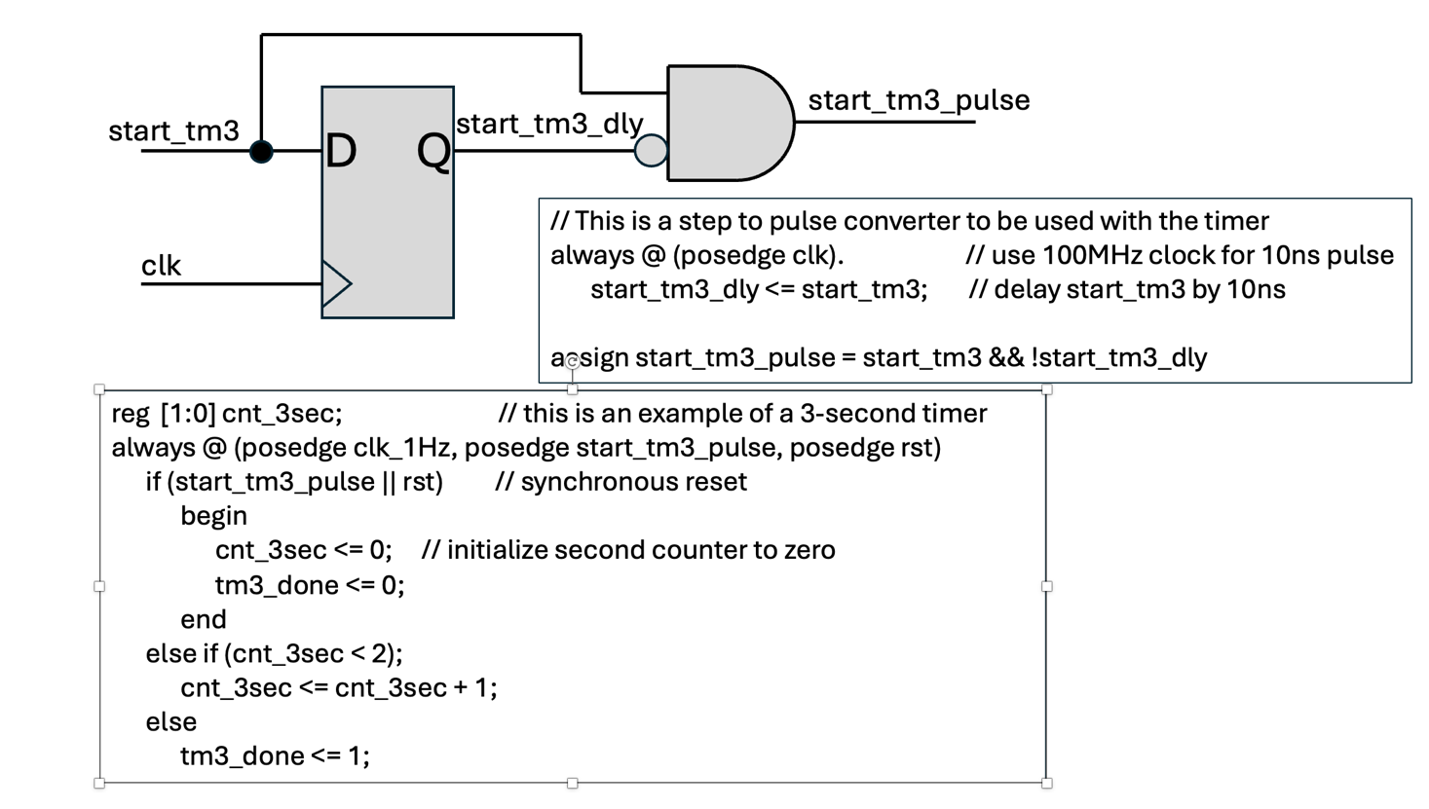

Designing a 1 Hz clock generator from a 100MHz clock signal
In a previous lab, you designed a slow clock that was much slower than 100MHz, but you were not able to precisely set the frequency because the 100MHz clock was divided by powers of 2.
Now we want to have a timer with a much more precise clock frequency. To do this, you can learn from the following example, which generates a 10Hz clock:

// A 10Hz clock from 100MHz example
reg [22:0] count; // make sure the count has enough bits to count to 5,000,000
always @ (posedge clk, posedge rst) // fclk is 100MHz
if (rst)
begin
count <= 0;
clk_10Hz <= 0;
end
else if (count < 5000000)
count <= count +1; // keep incrementing until you hit 5,000,000
else
begin
count <= 0;
clk_10Hz <= !clk_10Hz; // invert the clock every .05 seconds
end

Extra Credit 1
Add crosswalk functionality to the simple traffic light controller (+40%). Draw a new State Diagram with this new crosswalk functionality. You will need to add two states to the basic traffic controller, MainG_CenterR_CrossC, and MainR_CenterG_CrossM.

Additional State Names Needed
- MainG_CenterR_CrossC - Main street light is green, Center street light is red, cross Center street light is on. When in this state, the Main street green light timer is extended to 20 seconds to give the pedestrians more time to cross Center street.

- MainR_CenterG_CrossM - Main street light is red, Center street light is green, cross Main street light is on. When in this state, the Center street green light timer is extended to 20 seconds to give the pedestrians more time to cross Center street.

Extra Credit 2
Control red, green and yellow LEDs through one of the PMOD ports (+20%).

Lab Report:
- Include final State Diagram showing all input and output signals (5 points)
- Include the code for the overall Traffic Light Controller (5 points)
- Include a test bench with waveforms that demonstrate correct operation (5 points)
- Include a Conclusion statement describing your fulfillment of the objectives along with your observations (5 points)
- In your conclusion statement, indicate the level of functionality (in percent) of your lab (5 points)
- Extra Credit 1 (10 points), Extra Credit 2 (5 points)

